Lab 3 EE2005 Electronic Devices and Circuits Week 6

Lab 3: AC Phasors

INTRODUCTION:

In this lab, you will apply your knowledge on phasor techniques to analyze some basic circuits comprising resistors and reactive components (i.e. inductors ). The objective here is to relate a theoretical understanding of impedance and phase to what can be observed using an oscilloscope. In the process, you will learn how to simulate a sinusoid output of an RLC circuit with LTSpice.

Learning outcomes
- Simulate output AC signals of an RLC circuit

- Explain from observation the dependence of impedance on the AC signal frequency

- Observe the superposition of multiple frequency sources in a basic circuit with reactive components

Lab Task 1: Applying phasor techniques using single source
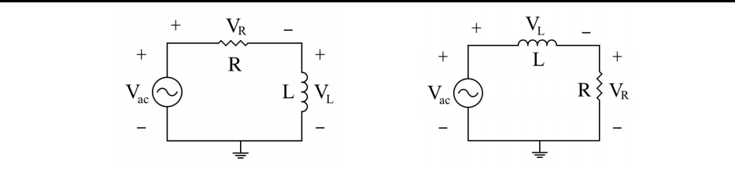

Fig 1a (left) & Fig 1b (right): Schematic of an RL circuit

1.1 Assemble the circuit of Fig. 1 in LTSpice, given VS = 5 sin(2πf t) V.

1.2 TA will announce in class on the resistance R = ____3_____ kΩ and inductance = _____2____ mH to be used.

1.3 To simulate AC signal (Vac), right click on the voltage source and select “SINE”. Set the DC offset, amplitude and frequency to 0V, 5V, and 10kHz respectively. Use shortcut "s" to add a SPICE directive then right click in text box and choose "Help me edit". You just need to select the tab “Transient” and set the stop time to 5e-3 (s). Then press OK to put the text command anywhere on the schematic. Press the Run button () to initiate the simulation.

1.4 Right click anywhere on the schematic, select “View”, and then select “Waveform Data”. Record the maximum amplitude VL (using Fig 1a) and VR (using Fig 1b) of the last cycle on at 10 kHz. To measure phase, the wave form of Vac should also be compared when you measure VL and VR.

1.5 Then set the frequency of the signal generator to 20 kHz and study the waveforms of VL and VR again. Table 2: Simulated values for Task 1

Simulated VL (Fig 1a) |  | Simulated VR (Fig 1b) |  | I (Calculate using VR)
Amplitude | Phase | Amplitude | Phase | Amplitude | Phase

- 10 kHz 1.906 68 4.516 152.9 1.5m -27.6

- 20 kHz 3.2 24 3.68 70.6 1.23m -14

What is the closest phase of the inductor voltage relative to the current used in your circuit at 10kHz and 20kHz?

For 10 kHz: ☐0º ☐-45º | ☐45º | ☐-90º | ☐90º
For 20 kHz: ☐0º ☐-45º | ☐45º | ☐-90º | ☐90º | _______ / 5

Semester A 2020/21 1 R. H. M. Chan

Lab 3 | EE2005 Electronic Devices and Circuits | Week 6
Lab Task 2: Dual source
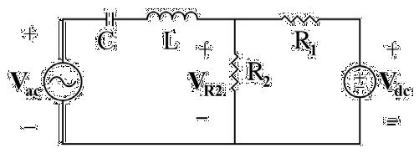

Fig 2: Schematic of circuit with two input sources with different frequencies

2.1 Assemble the circuit you have analyzed in Fig. 2 in LTSpice, giving R1 = 2 kΩ, R2 = 1 kΩ, L = 10 mH, C = 33
nF, Vac = 5 sin(2πft) V, and Vdc = 9V. Use an additional voltage source to apply a DC voltage of Vdc = 9V.

2.2 Keep the amplitude of the AC signal at 5V and set the frequency to 5 kHz.

2.3 Measure VR2. Observe the waveform of VR2 in both AC mode and DC mode. You should notice two frequency components on the waveform display in LTSpice.

2.4 Capture the screenshots two waveforms of Vac and VR2 in the space provided below. Identify the various frequency components on your graph. Note down the amplitude of the AC wave from VR2 and its phase relative to Vac.

2.5 Then adjust the AC signal frequency to 20 kHz and simulate VR2 again.

Capture a screenshot of waveforms of Vac and VR2 at 5 kHz and insert below:

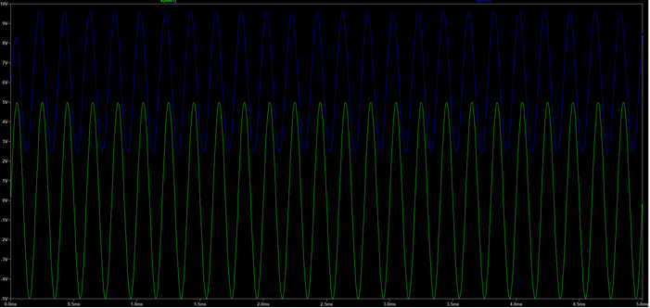

At 5 kHz, VR2 = ___6_____ (DC component) + __9.55(sin2π*5000 + 43.2)________ (AC component)

Capture a screenshot of waveforms of Vac and VR2 at 20 kHz and insert below:

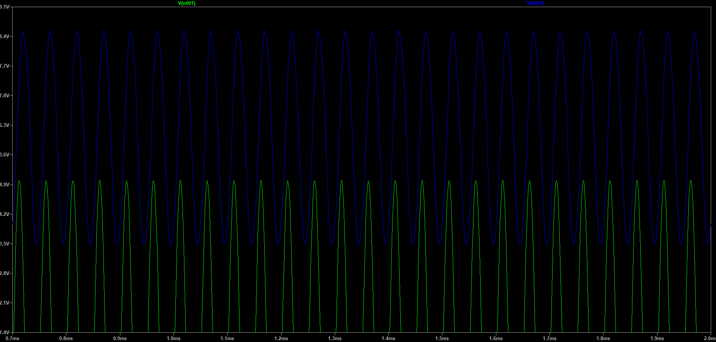

At 20 kHz, VR2 = ___6_____ (DC component) + ___8.54(sin2π*20000 – 48.56)_______ (AC component)

2.6 What is the difference in DC offset between your results from Lab Task 2 and Lab Task 1?

☐ No difference ☐ positive DC offset ☐ negative DC offset ________/ 5

Semester A 2020/21 2 R. H. M. Chan

